Forget Your Goals – Look at Your Habits!
“We are what we repeatedly do – Excellence , therefore, is not an Act , it is a Habit.”
Aristotle
Deirdre Murray of PEOPLE RESOURCES explores the neuroscience behind our daily habits and why New Year’s resolutions ultimately fail and offers 7 proven steps to help you start a small positive habit that will set you up for 2020 and beyond! Habits take deliberate practice in order to become engrained. We form our own habits and then they in turn form our traits. If we continue with certain unhelpful habits and are unaware of them, they can become our normal behaviour and over time our temperament. We do them automatically. We are what we do.
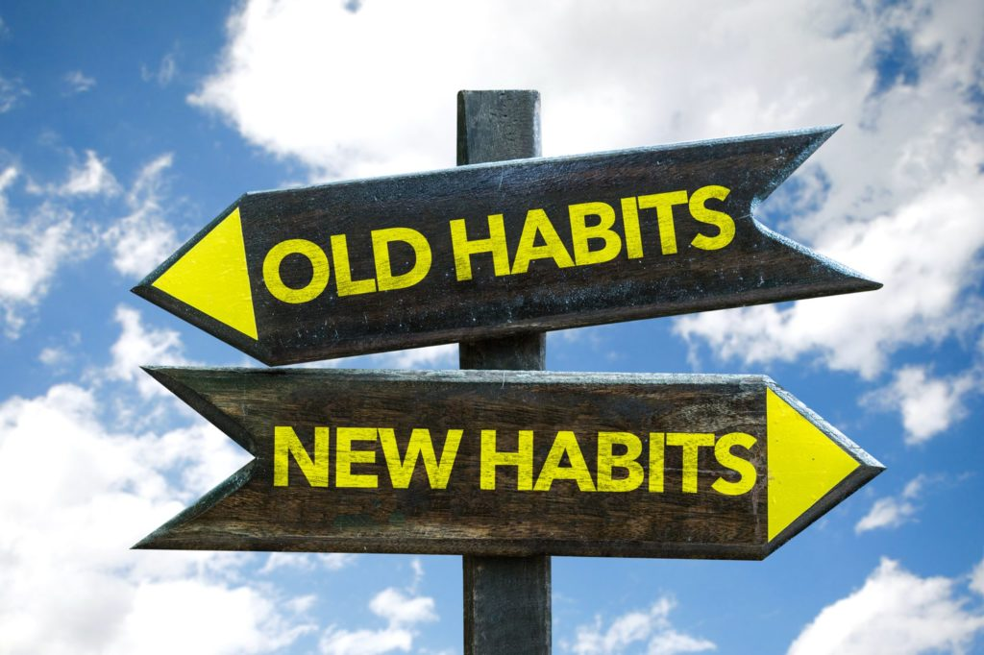

How are you getting on with your New Resolutions? We start out the year with great gusto and join the gym, attend for a few weeks and then gradually life gets in the way; the weather is terrible; the nights are dark; we’re tired after work and over time we ultimately stop going. “At least I tried,” you say to yourself. “I’ll start again in September.”
In order for any habit to stick it has to be repeated over and over again to such a point that it requires no thought. We do it automatically. Most of your thoughts and actions are the same as they were yesterday. If you are so used to going to the gym or walking every evening, it would feel strange not to do it. Behaviours and habits are learned rather than innate. They develop through constant repetition and reinforcement. We used to think that it took only 21 days to form a habit. Recent research by Lally et al shows that it takes anything from 18 days to 254 days depending on what type of habit you want to change – on average it takes 66 days.
One study looked at weight loss if someone cut down on milk in their coffee. This might seems quite minor, but the study showed that those who changed from putting half and half milk in their coffee and starting taking it black, lost over 35lbs in weight loss over 5 years.

“We first make our habits and them our habits make us.”
John Dryden, 17th writer
What might surprise you, is that recent research from neuroscience tells us that up to 95% of our behaviour is driven by our subconscious and that 45% of our habits rule our daily routines in any given day. (Wood et al, University of Southern California). These are our best responses to particular contexts. Once these habits are engrained, we are more likely to repeat them and they become routinised. It’s like a jeep stuck in the mud. We rev and rev the engine thinking this will get us out, only to find that we become more and more entrenched. It is only when a tow truck arrives and drags us back up onto the highway that we can progress down the road.
Changing to positive habits requires us to make a conscious choice to change the stimulus that triggers our behaviour. Over time this creates a new neuronal pathway in the brain. As a river carves out a deep channel on its route to the sea, so our neural pathways can become entrenched.
What are Habits?
There are 4 main criteria that make up a habit:
- Habits are a sequence or chunk of behaviour or thought, triggered by a particular cue.
- They are learned over time by being repeated over and over.
- They are persistent and fixed, once formed, and therefore hard to break.
- They are performed automatically
As we know, habits can serve us well. They can get us through tough times of stress and help to override motivational tensions in many contexts but as we all know, they can be positive or negative. We can continue to stop by the garage for the bar of chocolate on the way home, or we can change our route and keep a piece of fruit in the car. The problem with bad habits is that once they become entrenched, the simple action of driving into the garage with automatically trigger you to buy a chocolate bar! In this particular context we perform the action automatically - the outcome or reward doesn’t need to be there as the habit is well-formed.
How are habits formed? The S-R(A)-O model
There are two different circuits in the brain that control habits - the striatum and the sensorimotor cortex. Every habit is driven by a three-part loop: a trigger (the stimulus or cue), the routine, (the behaviour, and lastly the reward, (the perceived benefit or outcome).
Initially there is a cue or stimulus, (a contextual prompt that starts the routine or behaviour); then we take an action or response that leads us to experience a reward (i.e. reinforcement of something positive or removal of something that you don’t like – e.g. stress anxiety) This gives an outcome whether it is a good or bad habit. The particular action leads to an outcome and we repeat it consistently. The context then becomes a cue (a stimulus-response reaction).

How Habits Form:

Goal-directed behaviour and habitual behaviour involve two different parts of the brain.
The pre-frontal cortex or the ‘Executive’ part of the brain and the striatum are involved when the action is goal directed. Then when it becomes habitual, this activates the sensorimotor cortex and it becomes routine.
Habitual behaviour is both physical and mental. Routine habits might include brushing your teeth driving your car to work, or playing a musical instrument you know well. Thoughts, feelings and mindsets and beliefs are also habitual and if we don’t pay attention to them, they can drive unhelpful behaviours.
Are you and ANT or a CAT?
How do you talk to yourself when you’ve made a mess of something? “You’re so stupid!” “ You’re always messing up!” Do you automatically resort to negative thinking patterns or ‘Automatic Negative Thoughts’ (ANTS), or do you pause and challenge those negative thoughts with Confident Affirming Thoughts? (CATS), asking yourself, “What have I learned from this? How has this bad situation benefitted me? What might I do differently in the future?
Here are 7 proven steps to help you develop positive habits in your life:
- Start small. Don’t take on something that would be a mammoth task for you. Make it manageable and realistic and something you can do every day.
- Pick a positive habit rather than focus on a negative one. A new positive habit is easier to adopt rather than try and stop an old negative habit – start with something easier, like walking 20 mins at a fast pace every day.
- Replace one activity with another – jog or walk rather than reach for the biscuits or crisps. Better still – bin them! If they’re not in the house you won’t be tempted.
- Start a habit chart. If you have one of those calendars with a blank box for each day, tick each time you keep up your positive habit over the next four to five weeks. Reward yourself at the end of the month with a small gift.
- Engage with someone to help you. A walking or running buddy will keep you on track and is more sociable than doing it on your own.
- Saying “I am a walker - I am becoming fitter and healthier” is much better than saying “I walk” as it will increase your motivation for behaviour change. See, hear, feel the change you want to seek.
- Be kind to yourself. Sometimes we slip up - we are only human and sometimes life gets in the way of our best intentions. It’s important to persist and just keep going. As Winston Churchill once said, “If you’re going through hell, keep going.” You’ll come out the other side.

Deirdre Murray, Founder and Director of PEOPLE RESOURCES, partners as an Executive Coach, Trainer and Facilitator with leading multinationals and public sector bodies across all sectors. Deirdre is co-author of “Emotional Intelligence (EQ) – A Leadership Imperative!” Her second book in the management briefs series, “Communicate with Impact! Communicate & Influence Successfully,” is out now at www.peopleresources.ie. She is a regular motivational speaker at conferences, seminars and on radio broadcasts and provides journal entries for leading business magazines.

