The Future for Hybrid Working
Are hybrid office teams here for good?

As we emerge from this pandemic, Deirdre Murray from People resources explores the advantages and disadvantages of hybrid teams and explores 4 key steps in making them work effectively.

“Latent demand for flexible working pattern changes has been unlocked. Employers must be ready to meet that demand with well-defined positions on hybrid and flexible working for every job role.”

University of Southampton Survey 2021.

We, the remote army of workers, are like grizzly bears buried deep in the snow, having spent two long winter months in hibernation and now emerging from home isolation into a sustained routine of hybrid working.

Two years ago, many employers would never have dreamed of sending all their office workers home. How would they get set up remotely? What about IT security? What would happen to overall productivity? How would they measure performance?

There are many frontline workers during the pandemic that have literally kept the country going and who didn’t have the option of working from home. They tended the sick and elderly, treated our illnesses, cared for us, fed us, manufactured goods, delivered to us and looked after us day in and day out and we are so grateful for all their efforts.

Now as we emerge from this pandemic, we have to seriously review the benefits and downsides of working in a hybrid world. Many organisations such as Amazon, Twitter and Facebook have always adopted flexible policies for remote working in order to attract and retain the best people. While this pandemic has been devastating for those who have been hospitalised, isolated or have lost loved ones prematurely, it has allowed us to capture the benefits of remote working and capitalize on it for the future, either on a full-time or hybrid basis.

We have been working virtually now for nearly two years which is a long time. Some workers have not noticed any change as they work remotely anyway. However, for many organisations, the challenge of the hybrid environment now has to be defined formally. For some organisations it has been really productive – their systems have all pivoted online and they can continue unabated. For others, the connection with customers and colleagues has dwindled and will take a significant period to rekindle.

One of the most positive aspects has been the end of the long commute, giving people have had much more freedom and family time. For others, however, it has been very lonely and isolating, particularly if they are new to the organisation and find it hard to know who’s who to connect with people and build up relationships on a personal level.

The most important aspect for employers as employees emerge from this pandemic is not just to lead but to lead with compassion. Employee wellbeing promotes true productivity and it cannot be underestimated.

Many employers feared that productivity would suffer. However, a recent study by the University of Southampton found that 54% of workers felt that productivity has increased not decreased as imagined. Ninety percent felt their productivity before and after Covid had either stayed the same or had improved. In addition, according to the WHO’s WHO-5 survey found that despite the need for social connection which many people missed, there was a high correlation between higher productivity and mental wellness.

In thinking about the future of hybrid teams, the Centre for Creative Leadership recently identified four key aspects in making it work.
This was defined as the 4 C’s: Core, A Collective mindset, Connection and Cohesion, as illustrated below.

The first step is to define in clear terms, the overall purpose and vision for the team. Secondly, it is critical to define what success would look and feel like for the team, as this might mean different things to different people.

Thirdly, the team needs to explore the level of social cohesion in the group. Do people feel safe to speak up, to challenge constructively? As Kim Scott outlines very well in her book, “Radical Candour,” there needs to be space for ‘optimal constructive challenge’ without the need for aggression, the desire to just placate someone or the fear of being put down by more prominent members or “gaslighted” when they put forward a valid suggestion or query.

Managing Strong Hybrid Teams: The Centre for Creative Leadership 2021

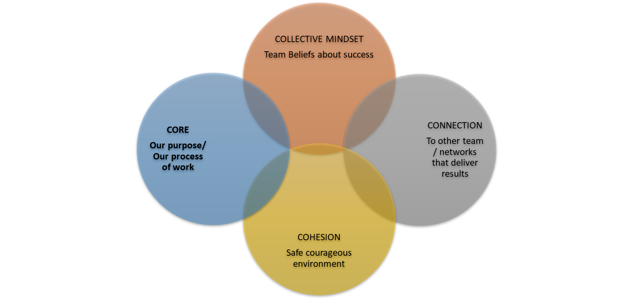
OUTCOMES
BUSINESS NEED

- Core: Articulate the vision and direction for the year ahead and set clear expectations for how you will work together. As Linda Grattan from the London Business School suggests, the two aspects that will determine the “why” you come into the office is FOCUS versus COLLABORATION. If people need to do deep concentrated work and can work remotely where they have the autonomy to focus – facilitate this. Where there is a specific project design, training event or brainstorming exercise where team collaboration needed, the very fact that people are together raises energy and oxytocin levels when people come together physically even within Covid Regulations.

- Collective mindset: It is really important to agree how you are going to “be” as a team. What will success look and feel like to the team? What are the values and behaviours that will underpin your success?

- Connection: How can the team maintain a high level of connection even when some are working remotely. Does the team want specific days agreed where everyone comes in rather than leave it ad hoc? There’s nothing worse than coming into the office to meet people and there’s no-one there!

Who are our keep stakeholders that we need to collaborate with? How will we communicate in this hybrid environment? What’s working currently and what do we need to change? I’ve noticed during the pandemic that many people are burned out with Zoom or MS Teams as it’s back-to-back all day. There’s no space for the brain to reflect and have some downtime. The brain needs time for focus and unfocus so it can be more reflective, innovative and creative.

- Cohesion: Lastly, and most importantly, team members need to operate in a psychologically safe environment, where there is high trust and high accountability. Constructive challenge to established norms is encouraged; different perspectives and opinions are respected and listened to. This has been a challenge for many new people or more reflective people during the pandemic on a remote basis, particularly when more extrovert employees take up all the air time. Any behaviour or conflict needs to be addressed in a constructive fashion and dealt with appropriately as it will just fester.

This is a time when the rubber meets the road in relation to hybrid working and will require huge flexibility and agility among employers and employees alike in making it work for everyone.

About the author
Deirdre Murray, Founder and Director of PEOPLE RESOURCES, partners as an Executive Coach, Trainer and Facilitator with leading multinationals and public sector bodies across all sectors.
Deirdre is co-author of “Emotional Intelligence (EQ) – A Leadership Imperative!” Her second book in the management briefs series, “Communicate with Impact! Communicate & Influence Successfully,” is out now at www.peopleresources.ie. She is a regular motivational speaker at conferences, seminars and on radio broadcasts and provides journal entries for leading business magazines.

